**BSCS FINAL PROJECT**

**Requirements Specification**

**Augmented Reality Human Scanner**



Project Advisor

**MAM MAHRUKH BATOOL**

Presented by:

**Group ID: F22BS100**

L1F19BSCS0035 Malaika Shafiq

L1F18BSCS0345 Fatima Anjum

**Faculty of Information Technology**

**University of Central Punjab**

Software Requirements Specification

Version 1

Augmented Reality Human Scanner

Advisor: Mam Marrukh Batool

Group:

|  |  |
| --- | --- |
| Member Name | Primary Responsibility |
| Malaika Shafiq | Research, Documentation, Information Gathering Implementation and Diagrams |
| Fatima Anjum | Research, Brainstorming, Documentation, Implementation and Diagrams |

#### 

# Table of Contents

Table of Contents

Revision History ii

1. Introduction and Background 1
   1. Product (Problem Statement) 1
   2. Background 1
   3. Scope 2
   4. Objective(s)/Aim(s)/Target(s) 2
   5. Challenges 2
   6. Learning Outcomes 2
   7. Nature of End Product 3
   8. Completeness Criteria 3
   9. Business Goals 4
   10. Related Work/ Literature Survey/ Literature Review 4
   11. Document Conventions 4
2. Overall Description 5
   1. Product Features 5
   2. User Classes and Characteristics 5
   3. Operating Environment 6
   4. Design and Implementation Constraints 6
   5. Assumptions and Dependencies 7
3. Functional Requirements 8
   1. Use-Cases 8
      1. Use-Case: Customer Sign-Up 8
      2. Use-Case: Customer Sign In 9
      3. Use-Case: Customer View Menu 10
      4. Use-Case: Customer Order Clothes 11
      5. Use-Case: Customer Review Clothes 12
      6. Use-Case: Brands/Stores Sign-Up 13
      7. Use-Case: Brands/Stores Sign-In 14
      8. Use-Case: Brands/Stores Request to Add an Item 15
      9. Use-Case: Brands/Stores Request to Update an Item 16
      10. Use-Case: Brands/Stores’s Deletion of an Item 17
      11. Use-Case: Brands/Stores’s Order Handling 18
      12. Use-Case: Admin Add Brands/Stores 20
      13. Use-Case: Admin Update Brands/Stores 21
      14. Use-Case: Admin Change Price 23
      15. Use-Case: Admin Delete Brands/Stores 24
      16. Use-Case: Admin View Customers’ Details 25
      17. Use-Case: Admin View Brands/Storess’ Details 26
   2. **Requirements Analysis and Modeling 27**
      1. State Diagram: Customer 28
      2. State Diagram: Brands/Stores Employee 29
      3. State Diagram: Brands/Stores Manager 30
      4. ER Diagram 31
      5. Sequence Diagram: Customer 32
      6. Sequence Diagram: Brands/Stores Employee 33
      7. Sequence Diagram: Brands/Stores Manager 34
4. Nonfunctional Requirements 35
   1. Performance Requirements 35
   2. Safety Requirements 35
   3. Security Requirements 35
   4. Additional Software Quality Attributes 36
5. Other Requirements 36
6. Revised Project Plan 36
7. References 37

Appendix A: Glossary 37

Appendix B: IV & V Report 38

Revision History

|  |  |  |  |
| --- | --- | --- | --- |
| **Name** | **Date** | **Reason For Changes** | **Version** |
|  |  |  |  |
|  |  |  |  |

# 

# Abstract

It's been decades since many shirts and pants manufacturers used procedures that only gave them a rough concept of the shapes and sizes their intended customers' intended customers as a result of the inclusion of AR Human scanning technology into human wear retail businesses, our research was able to amass a large collection of AR human scans from across the world. Using the mean width, instep height, and heel width of all the body scans in each length class, these results were then averaged. The findings of this study show that the mean body measurements vary widely between regions, genders, and consumer groups. It is recommended that each length class include different body shapes to accommodate the needs of as many customers as possible. Old last grading tables should be updated to reflect the body dimensions of today's clients, since human clothes intended for one group of individuals may not fit another.

# 1. Introduction and Background

The human perception of admiration and ability to pay is largely influenced by the visual composition of clothes on your body. With the widespread usage of smartphones throughout the world, there has been a significant increase in the use of apps connected to shopping, particularly for those who do not have enough time in their daily routine to go to the store and get what they need. Such an app that allows customers to measure their body and see how the clothes look on their body is a must-have feature. Additionally, the app displays information about the clothes, such as their degree of comfort, their fit, and their classification; it also shows how much each body costs, so customers can make a more informed purchasing decision before purchasing. This makes it easier for the consumer to choose the right clothes for their requirements without any hassle. Customers will be able to purchase clothes in a fun and quick method, making it a memorable and exciting experience for them. Creating an AR body scanner app is the goal of this project. We're using a new augmented reality capability in this app to get an approximate measurement of our body. Scan takes less than 10 to 15 seconds, and a list of clothes from all of the companies listed on the app for that specific size is recommended within that time. With the use of our smartphone camera, we can scan both of our bodies in a matter of seconds and obtain body data points that map our body morphology to the nearest millimeter. First, a picture of a body is scanned, and the size of that body is determined by the app. On the basis of image processing and AR scanners, we estimate that the body size is roughly S,M,L,XL,XXL. On the backend, we use a dataset of 3 to 4 body brands, which presents the clothes of all the brands in the precise size it was scanned in. In other words, it will display the 8-digit clothes of every brand. It will be able to find clothes for both men and women in the 8 9 or 10 size range.

With the help of the app, we will be able to see all kinds of bodywear. If a person rejects the body, it will offer additional scanned images of the clothes in the same size. Because of this, a person may inspect and wear the photograph by displaying the mobile scanner to the body. This is our primary goal, and its usefulness is to accurately categories a person's opinions about an internet business both manually and via their imagination. In a few seconds, AR Body Scanner is supposed to scan your body using your smartphone's camera and capture 10 data points that map your body morphology for both bodies. Plus, members may save their body measurements in their profile so they can utilize them whenever they need to purchase online or in a store. Retail stores may also benefit from using AR human Scanners. AR human Scanner mats rather than walls are used in this experience, allowing store athletes to assist you in finding the right body for your body. Entering a guest mode allows you to scan the body of relatives and friends while shopping for yourself. AR human Scanner is an excellent tool for parents who are trying to find out what size cleat, basketball body, or runner their child requires.

## Product (Problem Statement)

Assume for a moment that you have a really hectic schedule, and you've been trying to find a little time out of your day to go shopping for a new pair of clothes, but you're also apprehensive about purchasing them online. If you don't know your exact body size, or if you do but aren't confident about the clothing fit, you may wish to size up. Because you have no idea how the clothes will appear on your body, it is impossible to tell whether or not you will like the purchase. As a result of our efforts, we are hoping to introduce new ideas into a sector that has made significant progress in the area of body size improvement.

## Background

Yes, in the past the related work has been done but it does not measure the human body and shows its accuracy within 10 to 15 seconds and measures a whole-body size and then determines a body. Full Audery Body Scanner app in a town is making a hype but it’s just making a 3D Scan of human body ordering within a few clicks. The Full Audery Body Scanner app enables the podiatrists and body care professionals to quickly and accurately 3D scans the body of the person and communicate their therapeutic decisions and bespoke corrections to Full Audery Body Scanner app that will 3D design. Many apps like this have been seen in a market that are relatively combined and make a proposed material for only body scan or only for body or hand but do not make sense for the whole terminology.

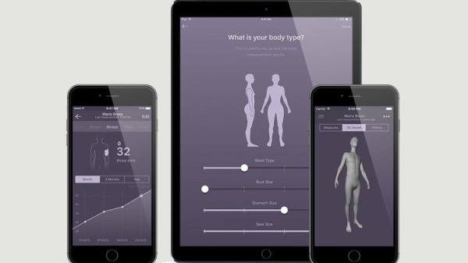

These are the previous works done but we are making a something unique which has not done before and make our best to do it.

## Scope

The goal of the AR-based web application is to make it easier for consumers to get clothes by giving them a clearer idea of exactly what they're getting before they buy it. Using augmented reality, buyers can easily purchase clothes by seeing how they will look on their Clothes, taking their body measurements, and learning more about the shoe. We'll use a database server to gather orders from the brand using a separate interface. Aside from enhancing the overall user experience, we want to change the industry's financial landscape.

## Objective(s)/Aim(s)/Target(s)

Apps for smartphones and tablets will allow customers to scan their body using their smartphones or tablets to ascertain their body size and then display them a range of available clothes in their size and the features of the clothes. After deciding on a pair of clothes, the consumer may try them on and make a purchase if they like them.

This application's goal is to enhance the brand's revenue while also providing a positive client experience. A brand-centric approach to the proposed solution is one aspect of the proposed solution. For the first time, the benefits of using these applications are explained. As a result, it suggests that the visual depiction of the brand of clothes will assist build client trust.

## Challenges

The following are some of the most difficult problems we'll have to deal with as we work our way through this project:

**1** Modelling in three dimensions

**2**  Storing/retrieving models

**3** Creating Augmented Reality apps

Blender Java Octave languages

**4**  AR Kit, AR core

## Learning Outcomes

We intend to be able to make 3D models from scratch, master new coding languages, and comprehend the workings of complicated software utilized in the creation of this application by the conclusion of this project.

## Nature of End Product

Using an augmented reality-based smartphone app, you can check whether a pair of clothes look fine on your body before you buy them. Customers will be able to make more informed decisions when it comes to purchasing an estimated body size that looks good on their body. A rotating human model would allow the user to see the item from all angles. Customers would also be able to see the clothe's comfort level, pricing, and user feedback in terms of stars on the screen, making it simpler for them to make a purchase decision. User dissatisfaction is minimized.

## Completeness Criteria

|  |  |
| --- | --- |
| **Work** | **Completeness** |
| Research on AR/3D Modeling | **20%** |
| Creation of 3D models of various clothes | **20%** |
| The interface of mobile application | **10%** |
| The application will display Items in AR | **30%** |
| Testing of application modules | **10%** |
| Complete mobile application software | **10%** |

## Business Goals

As a company, our objective is to go from traditional manuals to augmented reality-based instructions, where the user may be directed creatively, and the user will feel at ease using it.

## Related Work/ Literature Survey/ Literature Review

The purpose of this research [1] was to assess the BodyScan platform's dependability and determine the variations in body loading characteristics across procedures using and without using a top-layer. Utilizing a BodyScan platform, participants were assessed using the WOT and WT procedures. In order to compare the two methods, the reliability and the assessed parameters were evaluated. ICCs were greater, CVs were lower, and most parameter values were higher in the wot procedure compared to the WT protocol. The WOT protocol outperformed the WT protocol in terms of dependability, according to the findings. When doing a plantar pressure test, we suggest removing the top layer.

For measuring body pressure, the BodyScan [2] platform system is one of the most regularly used clinical instruments. System repeatability and the range of loading parameters seen in the normal body were the goals of this experiment. Calculating intraclass correlation coefficients and coefficients of variation across the three repeated trials in the same session was used to determine intra-session repeatability An average of the three trials in each session was used to calculate ICCs and CVs for inter-session repeatability. Results With an average CV of 28%, the ICCs were moderate to excellent repeatable tests for all of our relevant variables.

With the help of [3] Xeto, customers may take a measurement of their body and get size recommendations based on that measurement.

Using a patented blend of computer vision, data science, machine learning, artificial intelligence, and recommendation algorithms, Nike Fit [4] has developed a new scanning solution for athletes. By measuring the whole contour of both bodies, it provides the opportunity to determine your ideal Nike clothe size.

Greyder's AR clothe [5] allows customers to choose from two options: male or female. It then displays a range of clothes for customers to choose from. You first scan a location where you'd want to try on your clothes before scanning your body to get an augmented representation of what you'd wear. Then you put on your clothes and see how they fit. Effortless A 10-second scanning procedure that scans two bodies at a time generates precise, unequalled data on the body of your clients, making it easier to discover the proper clothes or orthotics the first time they use the system.

**1. Houzz**

A fantastic site for furniture and home products vendors,[6] Houzz is a popular augmented reality software for laying out and designing interiors. As a home renovation software, Houzz has ecommerce capabilities, making it possible for users to explore and purchase things directly from the app. In order to create a realistic visual, the "View in My Room" function employs 3D technology to insert objects into a snapshot of the user's house. It even depicts how the product would appear in various lighting conditions. Consumers may browse for a new sofa right from the comfort of their own home.

**2. IKEA Place**

[7] IKEA Place is another of the[7] AR applications for iPhone and Android that deals with home décor. It's a no-hassle way for customers of the Swedish furniture company to get their purchases inside their homes.

With this software, you'll be able to view the full picture, taking into consideration the layout of your complete house. Easy drag-and-drop and the chance to view other colours nearly detract from the joy of the IKEA shopping experience. But there are still no meatballs.)

**3. YouCam Makeup**

YouCam Makeup is the next augmented reality app on our list[8] (also available for Android and iOS). In this case, the focus shifts away from interior design and more toward the fine art of makeup. Even though you can try on samples at the beauty counter, fluorescent lighting may fool your eyes, and it doesn't take into consideration the normal circumstances of a selfie's lighting, so buying makeup is often a gamble. YouCam, on the other hand, uses AR technology to let customers examine a wide range of popular cosmetics.

**4. GIPHY World**

GIPHY Universe's world would be a lot more vibrant and interesting if it existed in the actual world. [9] Animated GIFs and augmented reality are combined in this software to create 3D graphics on images and videos (a lot like Snapchat does). Try GIPHY World if you want to give your social media posts a more personal touch. Enhance the visual appeal of product images for social media users by using graphics and animations.

**5. Google Lens**

Google Lens, an Android-exclusive AR software, improves the search experience. [10] If you want to learn more about anything, launch the app instead of entering in a text-based inquiry. There is no limit to what Google Lens can do for you when it comes to figuring out what you're looking at. In addition, if the item is on sale online, you'll be able to find out where to get it. This is just one of the many reasons why including a visual search strategy into your SEO plan is so critical. Google Lens may also be used from inside the Google Photos app (an iOS hack!) and through Google Assistant.

**6. Augment**

Another popular AR app for home items is Augment. [11] It's important to note that Augment is designed specifically for e-commerce business owners who may use the programmed to produce augmented photos of their merchandise.

Your own AR experience, whether it's on your mobile app or website, or at an in-person activation or through some other channel, is then ready to use these assets. Pop-up stores, farmers markets, special events, and other ephemeral physical retail initiatives may all benefit from it.

**7. ROAR**

Another great augmented reality app for company owners is ROAR. [12] Create an AR-powered online shop accessible by scanning product packaging at home, integrate AR into print marketing, and even discover which goods and categories are most popular when encountered via AR.

The app improves both in-store as well as at brand experiences for consumers by offering richer, more interesting content and information about the goods they are interested in. It's possible for them to look at reviews, see prices, and even make a purchase directly from the app.

**8. Amikasa**

[13] iOS-only Amikasa is one of the AR home-furnishing applications available (no Android version is currently available). Shoppers may build a coherent room without having to go to every store or website by using Amikasa, which collects items from all across the web. It's possible for users to make purchases without leaving the app. Remember that the more channels you have, the more chances you have to convert customers. Amikasa may be a fantastic place to list your household products if you're selling them.

**9. Snapchat**

Certainly, Snapchat is a popular social networking programmed with a younger demographic, entertaining effects, and self-destructing communications. If you didn't already know, it's also an AR app. [14] AR is on display in the wacky-face filters. Snapchat marketing and AR may be included into a brand's strategy by establishing a presence and investing in branded filters. You may learn more about how you can utilize Snapchat to advertise your company by reading this article. In order to keep customers engaged, you need to provide them with more relevant and interesting material. It's possible for them to look at reviews, see prices, and even make a purchase directly from the app.

# Overall Description

## Product Features

* Allow the users to see their size online.
* Allow the users to get trusted to the online sites.
* Allow the users to review the products they have tried, and see the reviews of others before trying.
* Allow the user to place an order at the desired brands
* Allow the brands to receive the order placed by the users.
* Allow the admins to add, remove, and update the offerings, brands (their information), and user information.
* Allow the user to view the desired clothe in front of their eyes

## User Classes and Characteristics

**User Classes:**

**1.** **Customers:**

Male and female customers of the brand.

**2.** **Brand:**

Male and female staff of the brand.

**3.** **Admin:**

Developers of Relish Mobile Application (Malaika Shafiq, Fatima Anjum)

## Operating Environment

|  |  |  |  |  |  |  |
| --- | --- | --- | --- | --- | --- | --- |
| Users | User Class | Frequency | Technical expertise | Security | Educational level | Experience |
| Customers | Primary | High | Not required | Basic | Basic English minimum to any level | Not required |
| Brand | Secondary | mediocre | Not required | Mediocre | Basic English minimum to any level | Not required |
| Admin | Primary | Low | High | High | BSCS | Basic |

## 

## Design and Implementation Constraints

**Environment:**

The application would require a flat surface to place the 3D object on.

**Hardware:**

iPhone with an A9 chip or above, which includes iPhone 6s/iPhone 6s Plus up to the latest iPhone.

iPod touch (7th Generation)

**Operating System:**

iOS 11 or higher

## Assumptions and Dependencies

1. The procedure of measuring the size of the body using the smartphone or tablet and then trying it on visually will be used by the other brands as well in the future.
2. Cell phones must have AR capabilities for our software to work.
3. The project is dependent on the variety of clothes of the brand.
4. A variety of clothes will not be modified throughout the project.
5. Assuming the user will grant permission to our application for the use of a camera to configure the base and show 3D objects.
6. The whole project is dependent on the brand’s variety of clothes.

# Functional Requirements

### Use-Case: Customer Sign up

|  |  |  |  |
| --- | --- | --- | --- |
| **Identifier** | | Customer Registration | |
| **Purpose** | | To show the process of registration for the customer | |
| **Priority** | | High | |
| **Pre-conditions** | | The application must be installed | |
| **Post-conditions** | | Data gets added to the database | |
| **Typical Course of Action** | | | |
| **S#** | **Actor Action** | | **System Response** |
| **1** | Sign Up | | Get Code for verification |
| **2** | Account Verified | | Process to the App |
| **Alternate Course of Action** | | | |
| **S#** | **Actor Action** | | **System Response** |
| **1** | Sign Up | | Show error message if the user already exists in the database |
| **2** | Sign Up | | Show error message if the wrong email is used |

**Table 1: Customer Sign up Use-Case**

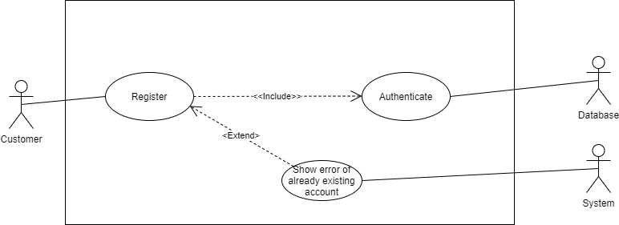

### 3.1.2 Use-Case: Customer Sign In

|  |  |  |  |
| --- | --- | --- | --- |
| **Identifier** | | Customer Login Process | |
| **Purpose** | | To show the process of login for the customer | |
| **Priority** | | High | |
| **Pre-conditions** | | The customer must be signed Up for this application | |
| **Post-conditions** | | The user gets signed into the application | |
| **Typical Course of Action** | | | |
| **S#** | **Actor Action** | | **System Response** |
| **1** | Sign In | | Get to the main page of App |
| **2** | Click Camera | | Access to the camera and find size |
| **3** | Dataset | | Find the size and get clothes from the brands |
| **Alternate Course of Action** | | | |
| **S#** | **Actor Action** | | **System Response** |
| **1** | Sign In | | Show error message if the user does not exist in the database |
| **2** | Sign In | | Show error message if wrong details are used to log in |
| **3** | Sign-In Change Password | | If a user forgets the password, he may change it |

**Table 2: Customer Sign in Use-Case**

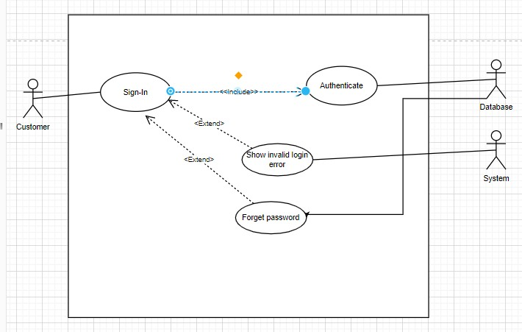

### 

### 3.1.3 Use-Case: Customer Size

|  |  |  |  |  |
| --- | --- | --- | --- | --- |
| **Identifier** | | Customer View the Size by Camera | | |
| **Purpose** | | To view the size using camera | | |
| **Priority** | | High | | |
| **Pre-conditions** | | The customer must be logged into the application | | |
| **Post-conditions** | | customer be able to view Size | | |
| **Typical Course of Action** | | | | |
| **S#** | **Actor Action** | | | **System Response** |
| **1** | View Size | | | Retrieve size using camera and get back to display screen |
| **Alternate Course of Action** | | | | |
| **Actor Action** | | | **System Response** | | |
| Picture not found | | | Show error message if the user did not take picture clearly | | |
| Network Error | | | Show error message network or internet signals is gone | | |
| White Background | | | Show error message if background not found | | |

**Table 3: Customer Sizing Use-Case**

## 

### 3.1.4 Use-Case: Customer Ordering Clothes from Brands

|  |  |  |  |  |
| --- | --- | --- | --- | --- |
| **Identifier** | | Customer Order from the brands | | |
| **Purpose** | | To order clothes according to your size and gender | | |
| **Priority** | | High | | |
| **Pre-conditions** | | The customer must have the brands Opened | | |
| **Post-conditions** | | customer order received by the brand side | | |
| **Typical Course of Action** | | | | |
| **S#** | **Actor Action** | | | **System Response** |
| **1** | Order Clothes | | | Check Size Open the brands find out respective gender and order Clothes and forward it to brand panel |
| **2** | Customer Details | | | Customer Details required for ordering |
| **3** | Pricing | | | Pay with online or by hand |
| **Alternate Course of Action** | | | | |
| **Actor Action** | | | **System Response** | | |
| Order Requirements | | | Show error message if the user requirements or not fulfill | | |

**Table 4: Customer Order Clothes Use-Case**

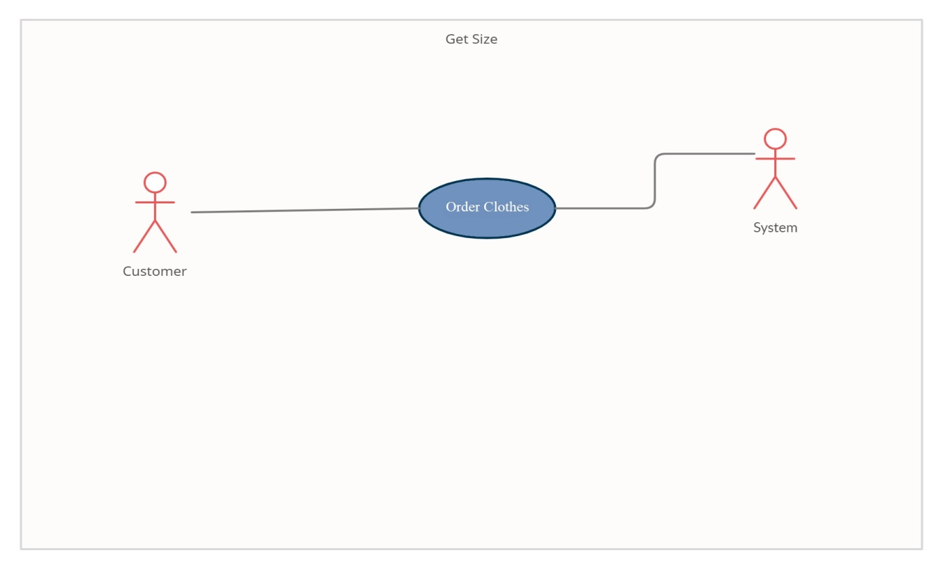

### 

### 3.1.5 Use-Case: Customer Review about App

|  |  |  |  |
| --- | --- | --- | --- |
| **Identifier** | | Customer review Clothes and Sizing | |
| **Purpose** | | To review App | |
| **Priority** | | High | |
| **Pre-conditions** | | The customer must have ordered the Clothes prior to reviewing | |
| **Post-conditions** | | Customer’s reviews are saved in the database | |
| **Typical Course of Action** | | | |
| **S#** | **Actor Action** | | **System Response** |
| **1** | Review Clothes | | Only if the user has ordered that Clothes and sizing they may rate it in stars |
| **Alternate Course of Action** | | | |
| **S#** | **Actor Action** | | **System Response** |
| **1** | Review Clothes | | Show error message that the user hasn't ordered this item first |

**Table 5: Customer review App Use-Case**

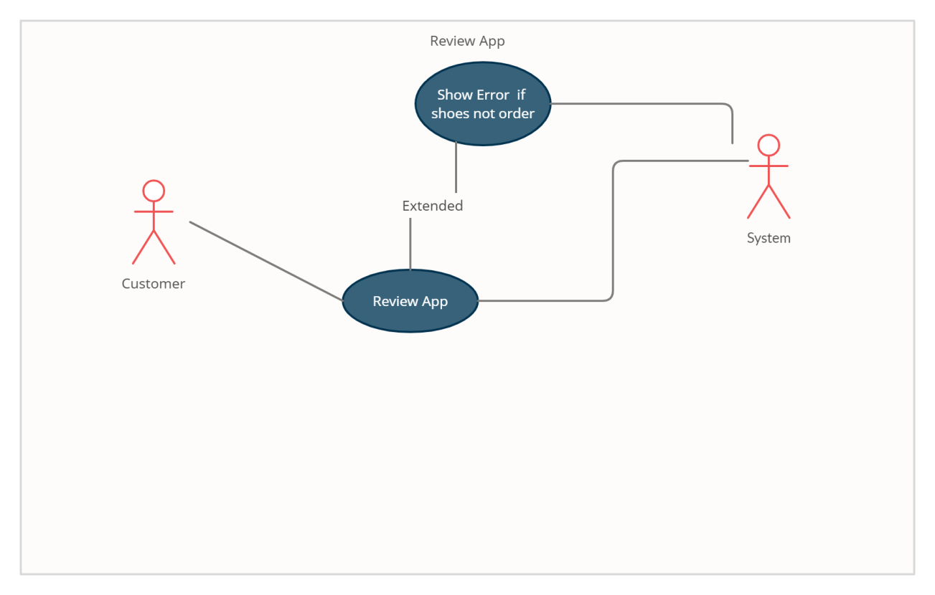

### 

### 3.1.6 Use-Case: Brands Request to Add an Item

|  |  |  |  |
| --- | --- | --- | --- |
| **Identifier** | | Brands Request to Add an Item | |
| **Purpose** | | To show the brands addition request procedure of an item | |
| **Priority** | | High | |
| **Pre-conditions** | | The user is signed in as a manager | |
| **Post-conditions** | | The request gets forwarded to the admin | |
| **Typical Course of Action** | | | |
| **S#** | **Actor Action** | | **System Response** |
| **1** | Request addition to the System | | Successfully added |

**Table 6: Brands Request to Add an Item**

### 

**3.1.7 Use-Case: Brands Request to Update an Item**

|  |  |  |  |
| --- | --- | --- | --- |
| **Identifier** | | Brands Request to Update an Item | |
| **Purpose** | | To show the Brands update request procedure of an item | |
| **Priority** | | High | |
| **Pre-conditions** | | The user is signed in as a manager | |
| **Post-conditions** | | The request gets forwarded to the admin | |
| **Typical Course of Action** | | | |
| **S#** | **Actor Action** | | **System Response** |
| **1** | Request an update to the Clothes | | Successfully Added- |
| **Alternate Course of Action** | | | |
| **S#** | **Actor Action** | | **System Response** |
| **1** | Request an update to the Clothes | | Show error of non-existing item |

**Table 7: Brands Request to Update an Item**

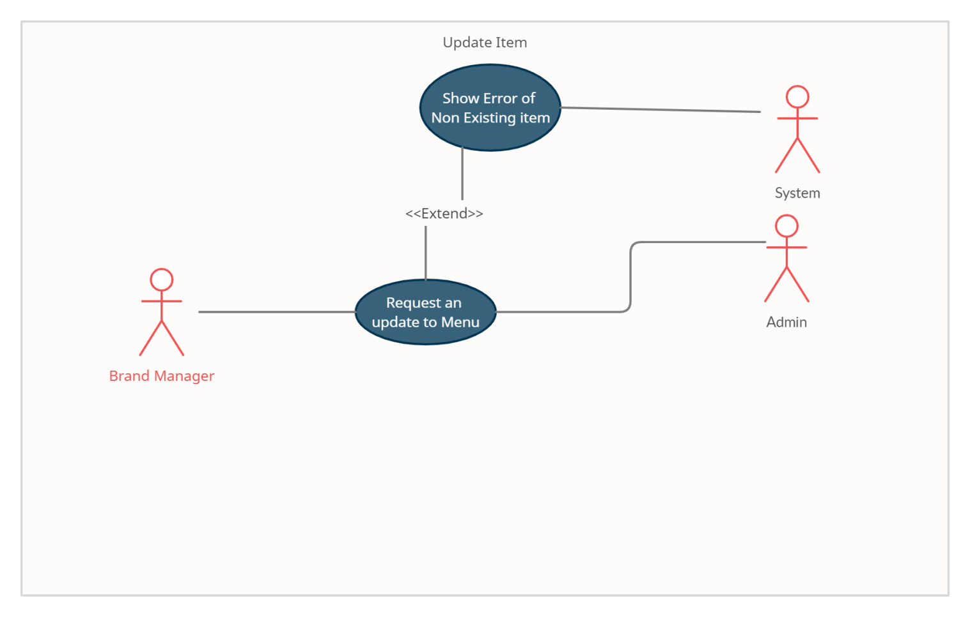**Table 7: Brands Request to Update an Item**

### 3.1.8 Use-Case: Brands Deletion of an Item

|  |  |  |  |
| --- | --- | --- | --- |
| **Identifier** | | Brands Deletion of an Item | |
| **Purpose** | | To show the Brands deletion procedure of an item | |
| **Priority** | | High | |
| **Pre-conditions** | | The user is signed in as a manager | |
| **Post-conditions** | | Item’s data gets removed from the database | |
| **Typical Course of Action** | | | |
| **S#** | **Actor Action** | | **System Response** |
| **1** | Remove an item from the menu | | Confirm removal from the database |
| **Alternate Course of Action** | | | |
| **S#** | **Actor Action** | | **System Response** |
| **1** | Remove an item from the menu | | Show error of non-existing item |

**Table 8: Brands Deletion of an Item**

## 

### 3.1.9 Use-Case: Brands Order Handling

|  |  |  |  |
| --- | --- | --- | --- |
| **Identifier** | | Brands Order Handling | |
| **Purpose** | | To show the Brands order handling procedure | |
| **Priority** | | High | |
| **Pre-conditions** | | The user is signed in as an employee | |
| **Post-conditions** | | Order information gets updated in the database | |
| **Typical Course of Action** | | | |
| **S#** | **Actor Action** | | **System Response** |
| **1** | Receives an order | | Accept the order |
| **2** | Item number | | Found |
| **3** | Price | | Found |
| **4** | Company | | Found |
| **5** | Size | | Found |
| **6** | Color | | Found |
| **Alternate Course of Action** | | | |
| **S#** | **Actor Action** | | **System Response** |
| **1** | Receives an order | | Cancel the order |
| **2** | Receives an order | | Update the order |

**Table 9: Brands Order Handling**

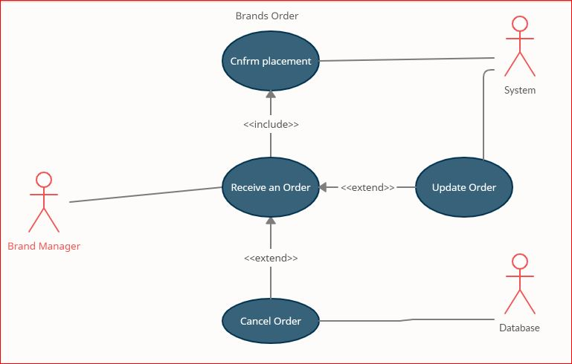

### 3.1. 10 Use-Case: Admin Add Brands and Store

|  |  |  |  |  |  |
| --- | --- | --- | --- | --- | --- |
| **Identifier** | | Admin Add Brands and Store Use Case | | | |
| **Purpose** | | To show the functionality of adding a new Brands and Store | | | |
| **Priority** | | High | | | |
| **Pre-conditions** | | Must have all the required information of the Brands and Store | | | |
| **Post-conditions** | | The new Brands and Store added to the database | | | |
| **Typical Course of Action** | | | | | |
| **S#** | **Actor Action** | | | **System Response** | |
| **1** | Add Brands and Store | | | Ad’s Brands and Store details to the database | |
| **2** | Name | | | Brands Name Found successfully | |
| **3** | Address | | | Brands Location Found Successfully | |
| **Alternate Course of Action** | | | | |
| **S#** | **Actor Action** | | **System Response** | |
| **1** | Find Brand | | Not Found | |
| **2** | Check Location | | Location not found nearby | |

**Table 13:** Admin Add Brands and Store

## 

### 3.1.11 Use-Case: Admin Change Price

|  |  |  |  |
| --- | --- | --- | --- |
| **Identifier** | | Admin Change Price | |
| **Purpose** | | To show the functionality of changing Clothes price from the application | |
| **Priority** | | High | |
| **Pre-conditions** | | The Clothes must exist in the brands database | |
| **Post-conditions** | | The updated database will have updated information of the Brands | |
| **Typical Course of Action** | | | |
| **S#** | **Actor Action** | | **System Response** |
| **5** | Update price | | Update the price of the respective Clothes using his coupon number and update database |
| **Alternate Course of Action** | | | |
| **S#** | **Actor Action** | | **System Response** |
| **1** | change price | | show error if new price < 0 |
| **2** | change price | | show error if the dish does not exist |

**Table 11: Admin Change Price**

## 

### 3.1.12 Use-Case: Admin Delete Brands and Store

|  |  |  |  |
| --- | --- | --- | --- |
| **Identifier** | | Admin delete Brands and Store | |
| **Purpose** | | To show the functionality of deleting the Brands and Store from the database | |
| **Priority** | | High | |
| **Pre-conditions** | | The Brands and Store must exist in the database | |
| **Post-conditions** | | The updated database will not have the deleted Brands and Store | |
| **Typical Course of Action** | | | |
| **S#** | **Actor Action** | | **System Response** |
| **1** | Delete Brands using ID or name | | Deletes the brand from database using ID or name |
| **Alternate Course of Action** | | | |
| **S#** | **Actor Action** | | **System Response** |
| **1** | delete Brands and Store | | show error if the Brands and Store does not exist in the database |

## Table 17: Admin delete Brands and Store User Case

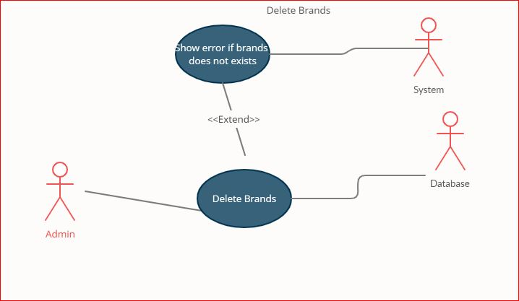

### 3.1.13 Use-Case: Admin View Customers’ Details

|  |  |  |  |
| --- | --- | --- | --- |
| **Identifier** | | Admin view customers’ details | |
| **Purpose** | | To show the functionality of admin viewing customer details | |
| **Priority** | | High | |
| **Pre-conditions** | | none | |
| **Post-conditions** | | Admin will be able to view all the customers’ information | |
| **Typical Course of Action** | | | |
| **S#** | **Actor Action** | | **System Response** |
| **1** | view Customer Details | | Retrieves all the customers in the system and show their details |
| **2** | Customer ID | | Checking the customer details name id and location |
| **3** | Pricing detail | | Check if he pays online or not |
| **Alternate Course of Action** | | | |
| **S#** | **Actor Action** | | **System Response** |
| **1** | view customers details | | show error if no customer exists |

**Table 18: Admin views customer’s details user Case**

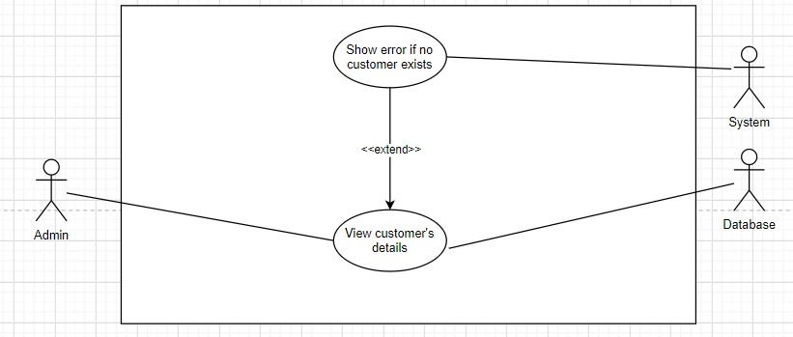

## 3.2 Requirements Analysis and Modeling

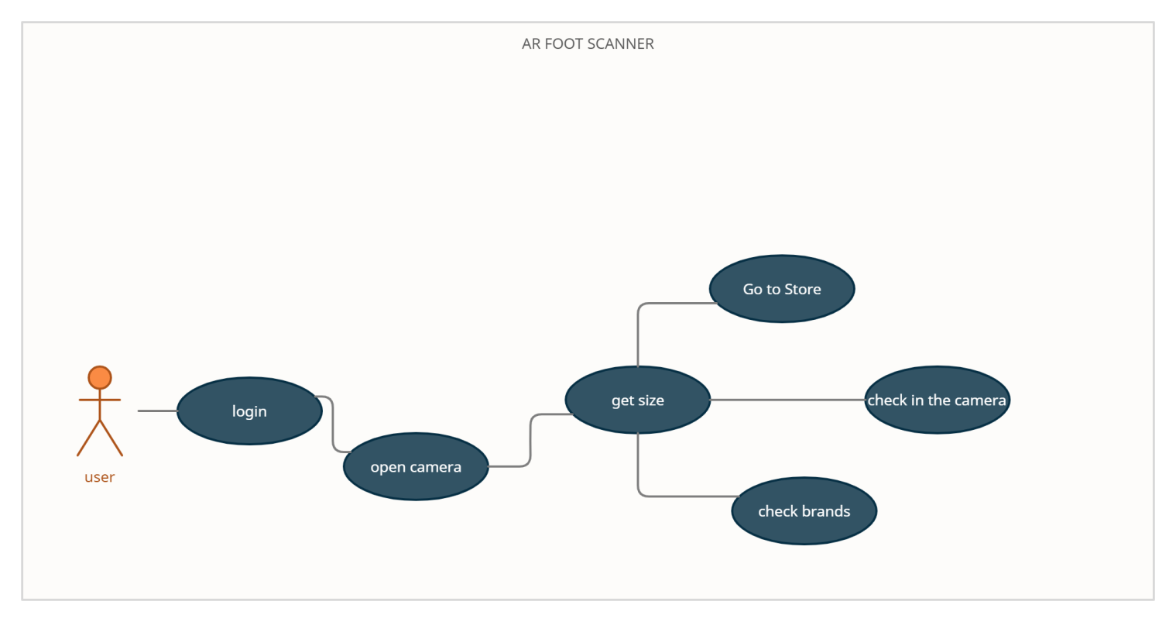

**Work Flow Diagram:**

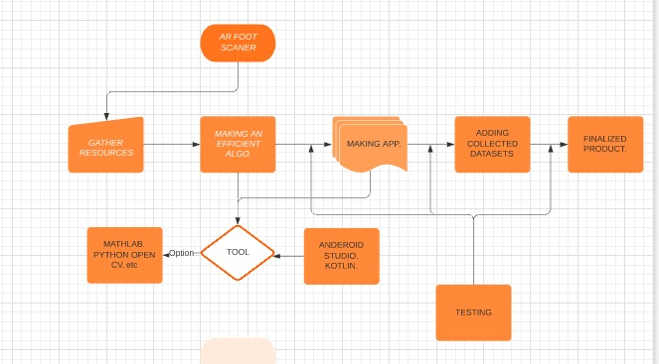

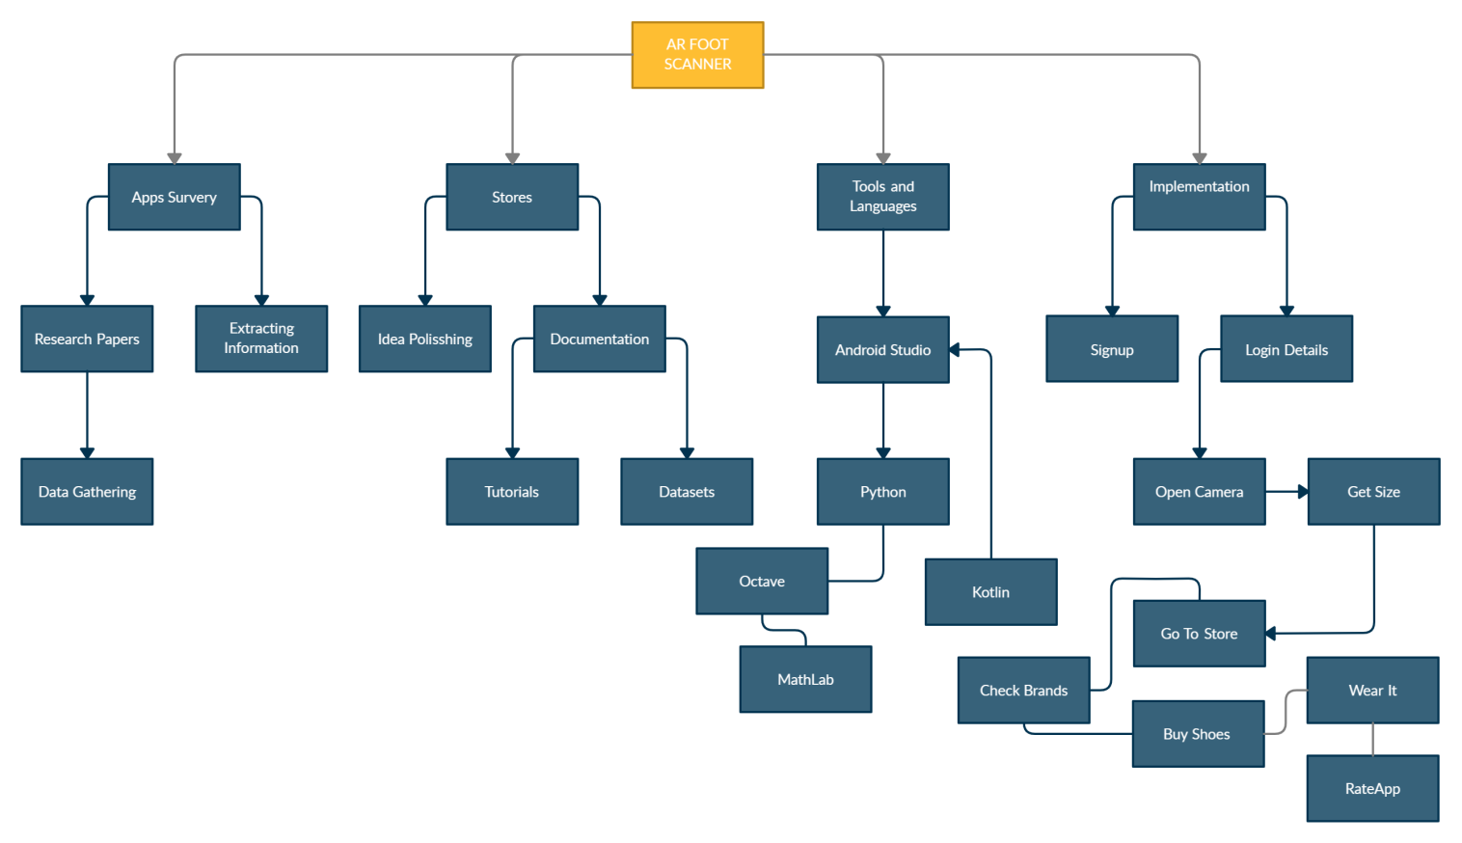

### 

### State Diagram: Customer

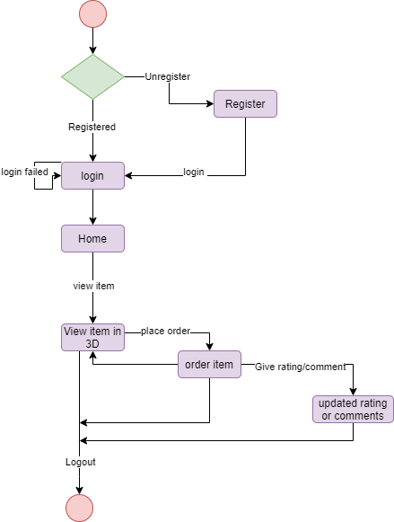

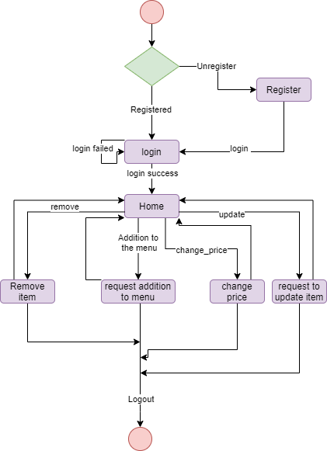

**3.2.2**  **State Diagram Brands Manager**

# 

* + 1. **State Diagram: Brands Employee**
    2. **Sequence Diagram: Customer**

# 

**3.2.5 Sequence Diagram: Brand Employee/Order-Taker**

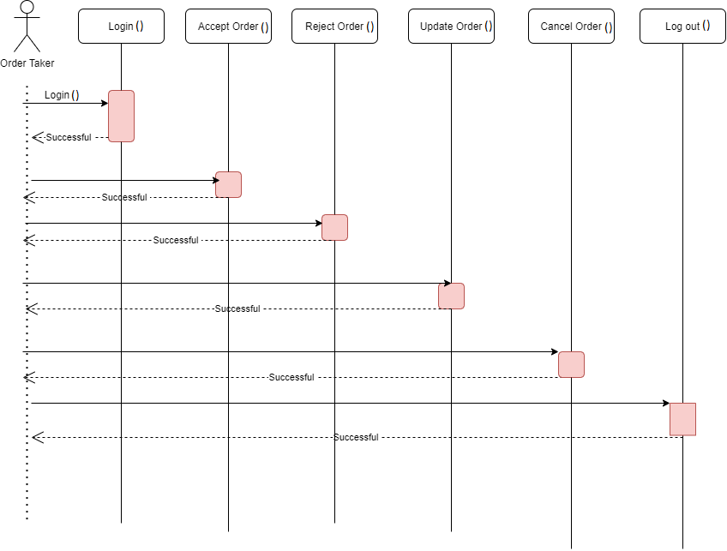

**3.2.6 Sequence Diagram: Brand Manager**

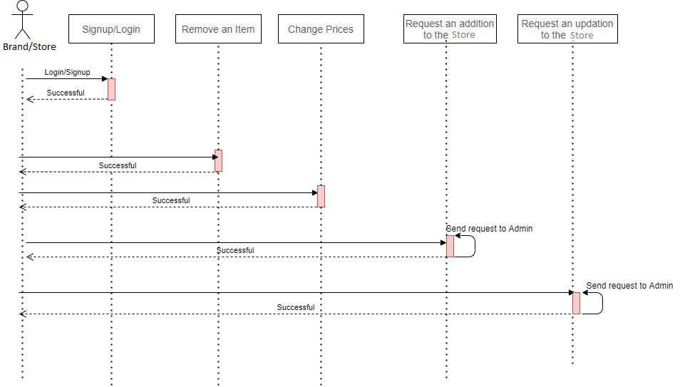

**3.2.7 ER Diagram**

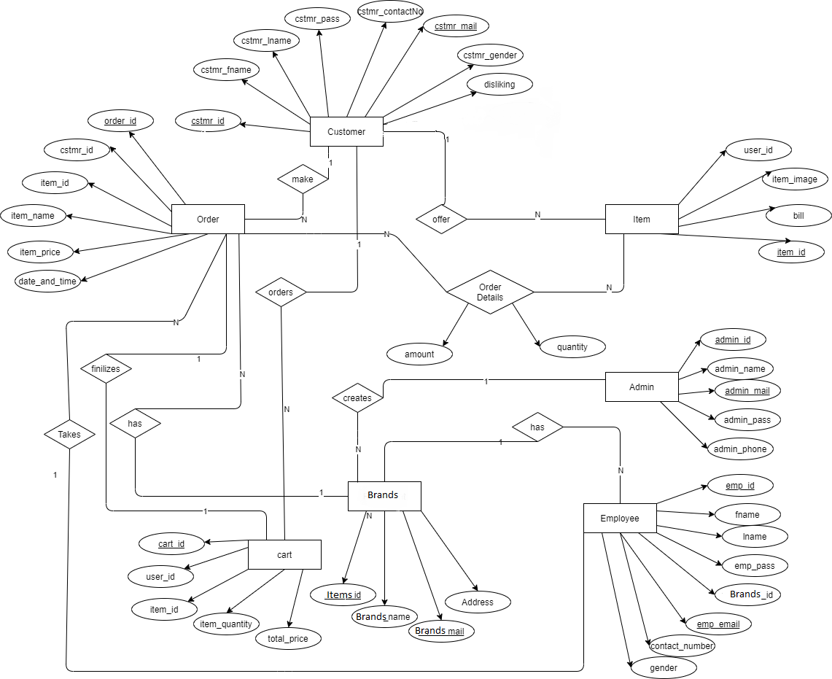

# Nonfunctional Requirements

## Performance Requirements

Augmented Reality applications need enough light to identify targets to show the perfect picture and guidelines. Smartphones with the android version greater than 8.0 would be eligible. Good camera hardware will lead to better detection of models

## Safety Requirements

As we are dealing with electronic equipment, we need to fully focus on what we are doing. A small mistake will be a result of laptop failure and the person should give their full attention to the guidelines. We will be using warnings at various points wherever user attention and focus will be required. We will be adding difficulty levels at the start of every task to mentaly prepare the user for that specific task.

## Security Requirements

We are not making any sign in option so will be not collecting any information of the user.We will also not demand access to their personal things.there would be only Camera access as we need that for augmented reality or microphone to hear beeps.

* + - Sensitive data is not stored outside the application’s designated database.
    - Passwords are not exposed through the application.
    - Sensitive data is not given out to any other entity or third party.
    - Sensitive data of the customers are not given out to the restaurants for any use.

Sensitive data of the brands is kept hidden from regular users.

## Additional Software Quality Attributes

Ease of use and ease of learning is an important outcome of our application.It should also be interoperability so we can add more models and equipment in it.

* + - Adaptability: The learning curve for this application will be very low, any user who has a basic knowledge of the English language will be able to use our application.
    - Availability: An Internet connection should be available to use the application. The application will be available through the apple store so users can easily download it.
    - Flexibility: We need it in case the softwares required to make the application are not available, so we can shift to others.
    - Interoperability: Maybe integrate in the future.
    - Maintainability: Maintenance will be needed when adding a new item to the menu.
    - Portability: In the future, rather than just scanning the table we can scan QR codes.
    - Reliability: Developers will make sure the application will not crash or hang.
    - Reusability: We can use code fragments from this application in any others in future
    - Testability: All available functionality like Interface, methods within the database section shall be fully tested before release.
    - Usability: usability should be as simple as possible. New users are able to learn (the use of the application) in a maximum of 5-10 minutes.

**4.Other Requirements**

The mobile needs a good camera of which the AR application can detect the objects.The datasets would be in the system and will be installed with application.Also Oracle online datasets will be attached within application.Also the virtual exercise would be on an animated laptop of which you need a big screen.

# Revised Project Plan kiakrn

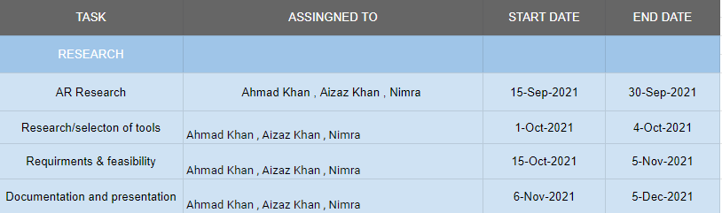

# References

**1)** Rutledge, P. (2012). Augmented reality: Brain Based Persuasion Model. E-Learning, E-Business, Enterprise Information Systems, & E-Government: EEE International Journal, 1, 45-57.

**2)** Pase, S. (2012). Ethical considerations in augmented reality applications. E-Learning, E-Business, Enterprise Information Systems, & E-Government: EEE International Journal, 1, 38-45.

**3)** Kerawalla, L., Luckin, R., Seljeflot, S. and Woolard, A., 2006. “Making it real”: exploring the potential of augmented reality for teaching primary school science. *Virtual Reality*, 10(3-4), pp.163-174.

**4)** <https://www.youtube.com/watch?v=1otpacSTnVE>

**5)** https://youtu.be/mEkzkKn00wE

**6)** Phan, V. and Choo, S., 2010. Interior Design in Augmented Reality Environment. *International Journal of Computer Applications*, 5(5), pp.16-21.

**7)** <https://apps.apple.com/pk/app/ar-shoe/id1449238675>

**8)** Saltan, F., 2016. The Use of Augmented Reality in Formal Education: A Scoping Review. *EURASIA Journal of Mathematics, Science and Technology Education*, 13(1).

**9)** Yuen, S., Yaoyuneyong, G. and Johnson, E., 2011. Augmented Reality: An Overview and Five Directions for AR in Education. *Journal of Educational Technology Development and Exchange*, 4(1).

**10)** Duh, H. and Klopfer, E., 2013. Augmented reality learning: New learning paradigm in co-space. *Computers & Education*, 68, pp.534-535.

**11**) Akçayır, M., Akçayır, G. (2017). Advantages and challenges associated with augmented reality for education: a systematic review of the literature. Educ. Res. Rev. 20 1–11

**12)** Alexander, T., Westhoven, M., Conradi, J. (2017). “Virtual environments for competency-oriented education and training,” in Advances in Human Factors, Business Management, Training and Education, (Berlin: Springer International Publishing), 23–29.

**13)** Azuma, R., Baillot, Y., Behringer, R., Feiner, S., Julier, S., MacIntyre, B. (2001). Recent advances in augmented reality. IEEE Comp. Graph. Appl. 21 34–47

**14)** Bailenson, J. N., Yee, N., Merget, D., Schroeder, R. (2006). The effect of behavioral realism and form realism of real-time avatar faces on verbal disclosure, nonverbal disclosure, emotion recognition, and copresence in dyadic interaction. Presence 15 359–372

**15)** Biocca, F., Harms, C., Gregg, J. (2001). “The networked minds measure of social presence: pilot test of the factor structure and concurrent validity,” in 4th Annual International Workshop on Presence, Philadelphia, PA, 1–9.

Appendix A: Glossary

Augmented reality (AR) is an interactive experience of a real-world environment where the objects that reside in the real world are enhanced by computer-generated perceptual information, sometimes across multiple sensory modalities, including visual, auditory, haptic, somatosensory and olfactory. AR means augmented reality. 3D means three Dimensions.

Appendix B: IV & V Report

**(Independent verification & validation)**

**IV & V Resource**

Name Signature

|  |  |  |  |  |  |
| --- | --- | --- | --- | --- | --- |
| **S#** | **Defect Description** | **Origin Stage** | **Status** | **Fix Time** | |
| **Hours** | **Minutes** |
| 1 |  |  |  |  |  |
| 2 |  |  |  |  |  |
| 3 |  |  |  |  |  |
| … |  |  |  |  |  |

**Table 3: List of non-trivial defects**